**$400 Hong Kong Dollar Ingredients**

(Including Breakfast, Lunch and Dinner)

* Quaker Oats 1.5Kg - Enough for 30 meals
  + Brought from Best Mart 360
  + Approximately $26 per 1kg
  + Price: $39

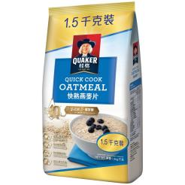

* Sau Tao Beijing Noodle 375GM (6 packets) - Enough for 30 meals
  + Brought from ParkNshop supermarket
  + Approximately $7.5 per packet
  + Price: $45

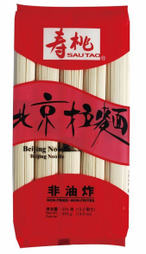

* Red Onion 3 pieces (large)
  + Brought from market
  + Approximately $3.6 for 1
  + Price: $11

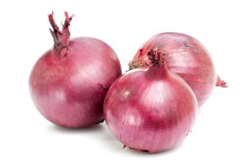

* Potatoes For Curry Chicken 6 potatoes – Enough for 30 meals
  + Brought from market
  + Approximately $2.5 for 1 potato
  + Price: $15

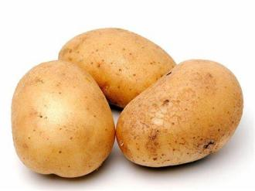

* Best Mart 360 Premium Thai Fragrant Rice 5kg – Enough for 30 meals
  + Brought from Best Mart 360
  + Approximately ~ $49 per packet
  + Price: $49

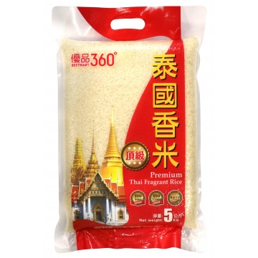

* Chicken Chops for Curry Chicken (Large) 6 Pieces – Enough for 30 meals
  + Brought from market
  + Approximately ~ $10 per Piece
  + Price: $60

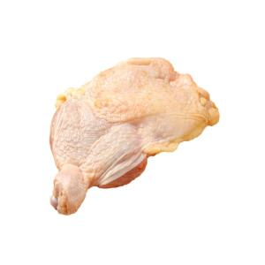

* Lee Kam Kee Curry Paste 3 Bottles – Enough for 30 meals
  + Brought from U Store
  + Approximately $16.9 per bottle
  + Price: $50.7

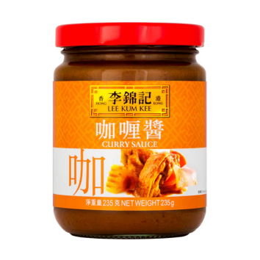

Kara Coconut Milk 6 packets – Enough for 30 meals

* + Brought from Welcome Supermarket
  + Approximately $8 for 2 packets
  + Price: $24

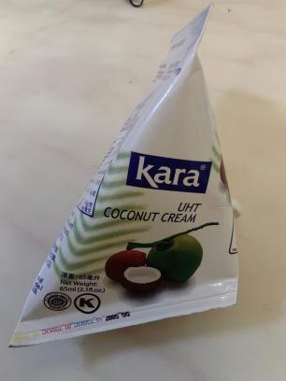

* Longevity Filled Evaporated 3 cans 400GM
  + Brought from welcome supermarket
  + Approximate $11 per can
  + Price: $33

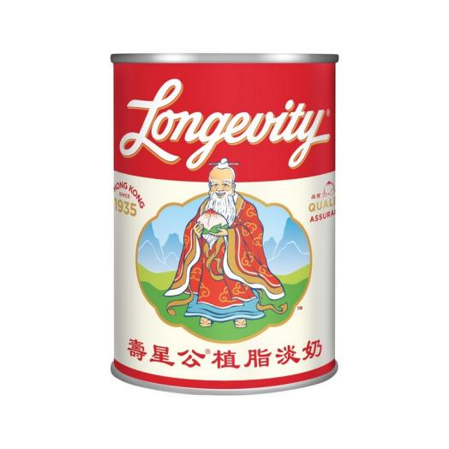

* Eagle Condensed Milk 3 Cans - 350GM per can
  + Brought from welcome supermarket
  + Approximate $13 per Can
  + Price $39

[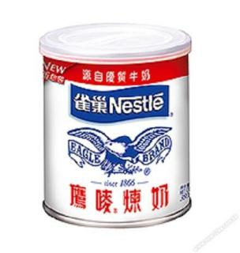](https://www.google.com/url?sa=i&url=https://www.668.com.hk/en/milk-cream/5594-5594-nestle-eagle-sweetened-condensed-milk-350g.html&psig=AOvVaw0KimHsyXHvficfzM83ZuPy&ust=1737682361356000&source=images&cd=vfe&opi=89978449&ved=0CBQQjRxqFwoTCIiO2rDZiosDFQAAAAAdAAAAABAE" \t "/Users/tangsinglun/Library/Containers/com.kingsoft.wpsoffice.mac.global/Data/Library/Application Support/Kingsoft/WPS Cloud Files/userdata/default/filecache/339537895/x/_blank)

* Knorr No MSG Added Chicken Powder 145GM – Enough for 30 meals
  + Brought from ParkNShop
  + Approximately $18 per Can
  + Price: $18

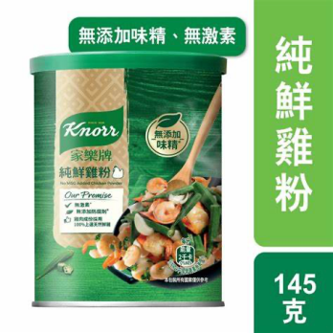

* Vegetable ~ 2kg – Enough for 30 meals
  + Brought from market
  + Approximately $9 For 1kg
  + Price: $16

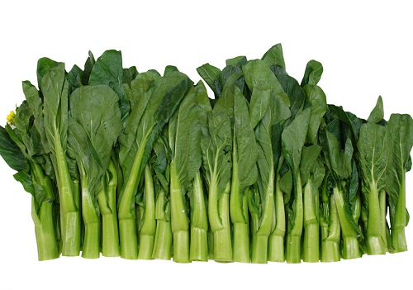

**Total Price: Approximate $399.7 (All in terms of Hong Kong Dollars)**

*Updated:31st January 2025 price subject to change*

**Ingredients And Menus (Total 90 Meals)**

3 Meals Per Day (Breakfast, Luch and Dinner) for 90 days

**These ingredients are based on portions. In case you don’t how to accurately divide it into portion. You can use a balance to weight the net weight of the ingredients and then divide it into portions base on the net weight.**

* Oat meal *– (30 meals) (Served for Breakfast)*

1. Fill the pot with water.
2. Add Oat.
3. Add Evaporate Milk.
4. To get sweetness, you can add condensed milk.
5. Stir well and served

* Beijing Noodle with Vegetable Soup Base *– (30 meals) (Served for Lunch)*

1. Fill the pot with water.
2. Add Chicken Powder.
3. Add one serving size of noodle into the pot.
4. Add a portion of Vegetables into the pot.
5. Served.

* Curry Potato Chicken with Rice *(30 meals) (Served for Dinner)*

1. Unfrozen the chicken chop.
2. Cut the chicken chop into small bite sizes around 20 pieces per chicken chop.
3. Mixed the chicken with flavour: salt and leave it for half an hour.
4. Keep the chicken inside the fridge.
5. Peel and Cut the Onion into Slices.
6. Peel the potato. Cut into small bite sizes base on your portion.
7. Fill the pot with water around 1000ml (base on your curry portion).
8. When water starts to boil, based on your portion add one bottle of Curry paste into the pot.
9. Base on your portion, add the potato and onion into the pot. For fast cooking, you can fry the potato and onion in a pan first.
10. Base on your portion, add one packet of Coconut Milk into the pot.
11. Add Salt when neccesary.
12. Wait till fully cooked.
13. Put inside the fridge when the pot of curry cools down.
14. When serve prepare one curry bowl portion for serving. Add 4 pieces of chicken into it, then reheat. You can have the option to reheat the curry chicken together with the rice during cooking.
15. Add 150 gram of raw rice, wash it and cook.
16. Serve it with **Rice**.

**Recommended Portion for Oat meal**:

* 50g of Oat.
* 500 ml of water
* Around 40 ml of Evaporated milk
* Around 35 gram of Condensed Milk

**Recommended Portion for Beijing Noodle with vegetable and chicken Soup base**:

* 1 unit set of noodles (there are total 5 units per packet).
* Chicken Powder 25 meals for 5 gram, 5 meals for 4 gram.
* Vegetable ~ add few bunches of vegetables or according to your needs.

**Recommended Portion for Curry Chicken enough for 10 days**:

* 1 bottle of Curry.
* 1 Large Chicken Chop, can be cut into 20 pieces. Total 6 Large Chicken Chop can be cut into 120 pieces which can be serve for 4 small pieces per meal.
* 3 Potatoes.
* 1 Onion.
* 2 packet of Coconut Milk.
* Water: 1000ml
* Salt and sugar for the chicken – according to your needs
* Rice per meal (not cooked) 150 gram.

***Total 90 meals***